6.95: a)
b)
c) Approximating 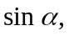 by 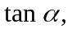 and using the component of gravity down the incline as 